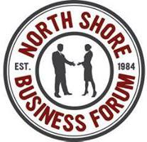

Learn [something that will be covered by speaker(s)] at North Shore Business Forum’s [Month & date] Meeting

Featured Speaker: [name and title of talk]

(DATELINE month date, year when you send out press release, for example: October 7, 2014, Beverly, MA) The North Shore Business Forum meets on Friday, [date of meeting] at Acapulcos, 900 Cummings Center, Beverly, MA. Registration begins at 7:15 AM, the meeting runs from 7:30 to 8:30. Admission is $10 at the door, and includes a buffet breakfast. Visit www.nsbforum.org for more information. The featured speaker is [two sentences that tell us who the speaker is and what he/she will speak about].

About the Speaker: [include a one-paragraph bio of the speaker and include their website URL if available]

The North Shore Business Forum, Inc. (NSBF) is a group of small business owners from Boston's North Shore who meet on the first and third Friday of each month for informal lectures given by business owners on a wide variety of topics. Members also introduce their business with a 30-second “elevator pitch” at each meeting. All business owners are welcome: future, past, profitable, experienced or beginning. Meetings are from 7:30 to 8:30 a.m. (registration starts at 7:15) at Acapulcos, 900 Cummings Center, Beverly, MA. The $10.00 admission fee includes a breakfast buffet. No pre-registration necessary.

Contact: Brett Kirkpatrick, NSBF President, 978-239-6335, Email: events@nsbforum.org.

# # #

